Shopee

Use-Case-Realization Specification: Make Payment

Version <1.0>

Revision History

| **Date** | **Version** | **Description** | **Author** |
| --- | --- | --- | --- |
| 17, Dec, 2023 | <1.0> | Final | Nguyen Huyen Anh |
|  |  |  |  |
|  |  |  |  |
|  |  |  |  |

Table of Contents

1. Introduction 2

1.1 Purpose 2

1.2 Scope 2

1.3 Definitions, Acronyms, and Abbreviations 2

1.4 References 2

1.5 Overview 2

2. Flow of Events—Design 2

3. Derived Requirements 2

Use-Case-Realization Specification: Make Payment

# Introduction

## Purpose

The "Making Payment" use-case is a fundamental business process that allows customers to purchase products from an online store, this will describe how users can make payment in Shopee platform.

## Scope

This document will describe how to purchase products in Shopee in a detailed way. This document uses MVC pattern in a sequence diagram and also supplies a class diagram.

## Definitions, Acronyms, and Abbreviations

MVC: Model-View-Controller

UML: Unified Modeling Language

## References

BMP01, version 0.1: Business Architecture Document

BMP03, version 0.1: Business Use-Case Specification: Making Payment

RD02, version 0.2: Use-Case Specification: Making Payment

AM01, version 0.2: Use-Case-Realization Specification: Make Payment

## Overview

This document explains the entire purchasing journey, from product selection to payment and order confirmation of use case “Making Payment”. This has the analysis in a textual description and a thorough design by using UML (sequence diagram and class diagram). It also lists all the derived requirements for that use case in the Design Model.

# Flow of Events—Design

# The user interacts with the system through the PaymentUI. The Payment UI component displays the applied-voucher message, the user's shipping and order information, as well as their payment information through Payment Controller by a method loadPaymentInfor.

Message Controller will get a message from Message Model. Therefore, Payment Controller continues to get information from User Model, Product Model, Voucher Model and Shipment Model respectively. After that, it calculates the order total, including taxes and shipping costs. Once the order total has been calculated, the PaymentController component places the order with the Payment UI.

When all is done, the user clicks on a Place Order button, this will redirect to Confirmed Page.

## Sequence diagram

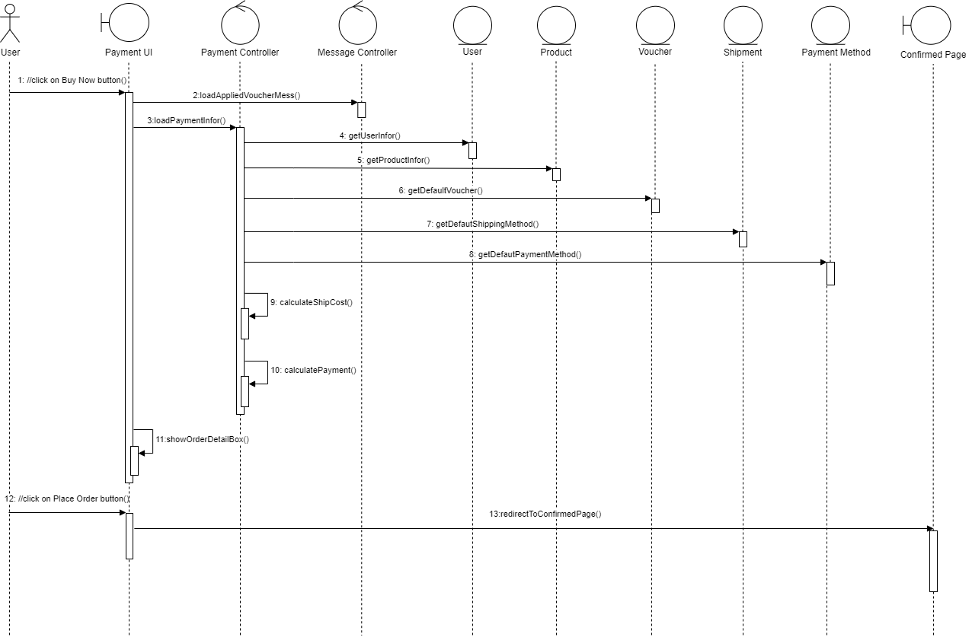

## Class diagram

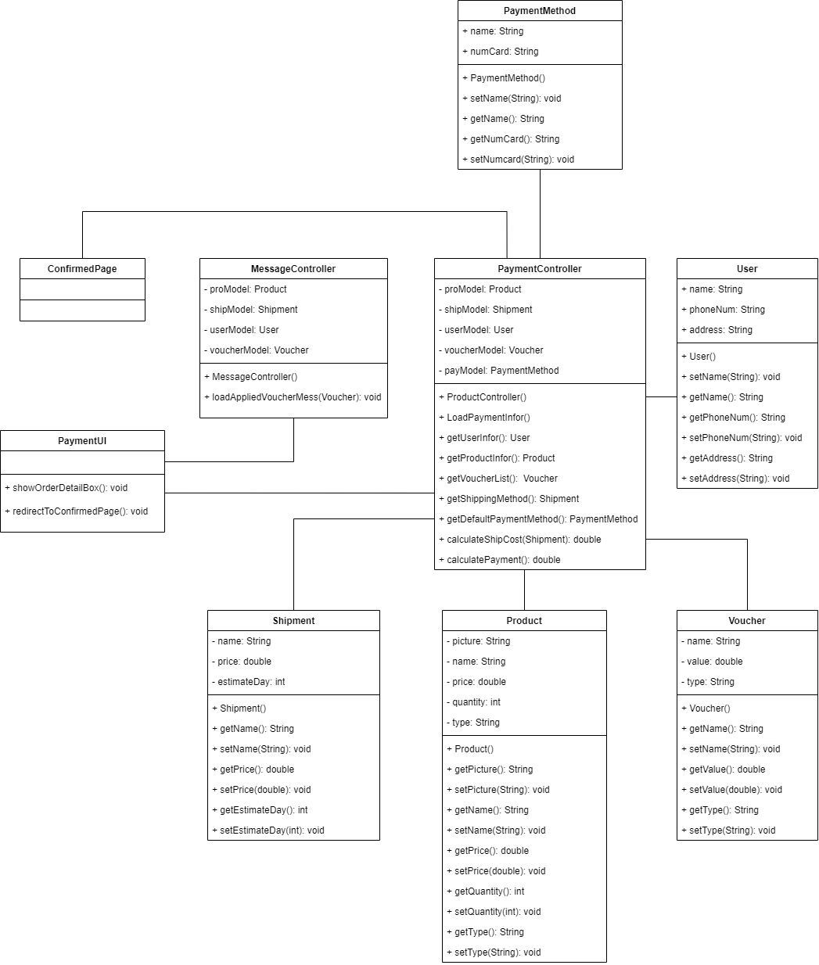

# Derived Requirements

**3.1. Response time:** The system should respond promptly to user actions, ensuring a smooth and responsive shopping experience.

**3.2. Security:**

Data Protection: Customer data, including personal information and payment details, must be protected with robust security measures to prevent unauthorized access and data breaches.

Secure Payment Processing: The payment gateway integration should adhere to industry-standard security protocols to safeguard sensitive financial information.